PARTS COORDINATOR

L2 SUPPORT Assigned the service call to parts coordinator

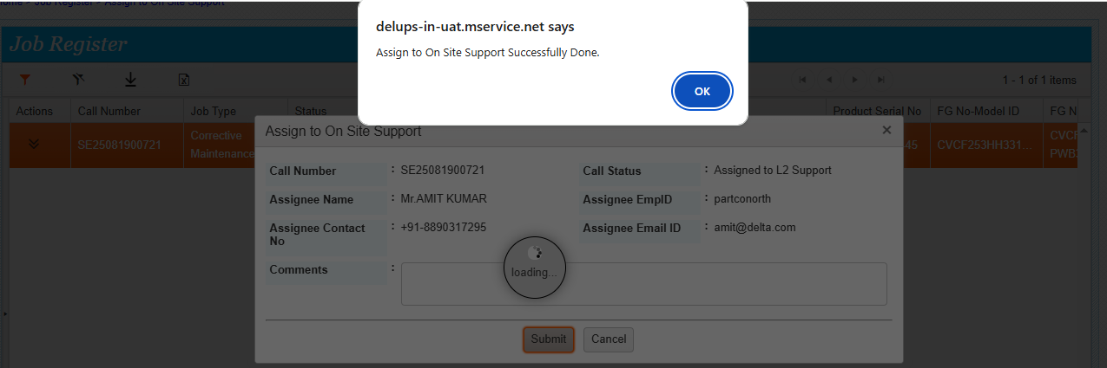

Parts coordinator do the following steps

URL- <https://mcis.deltaiserve.net/>

1)Type the URL , enter the login credential and do the login

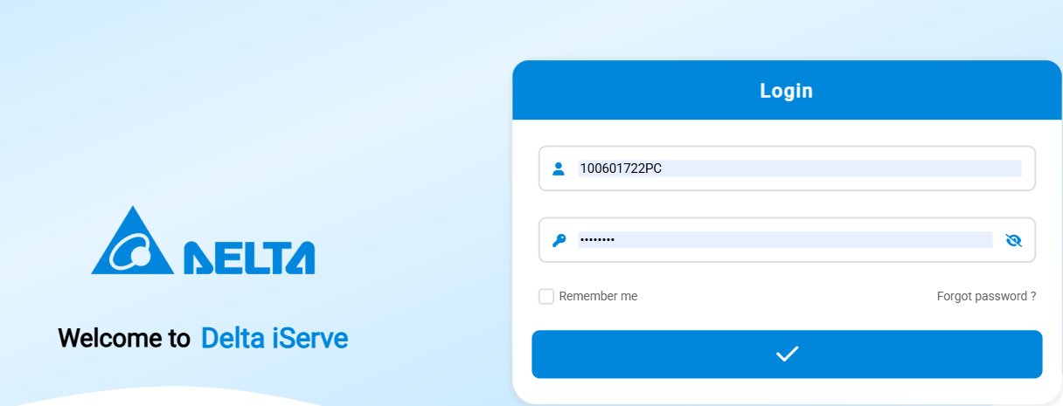

2) Go to service job management and see the assigned calls

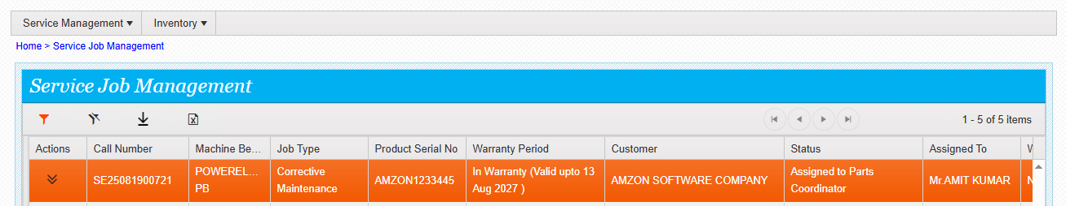

Click on edit and see the details .

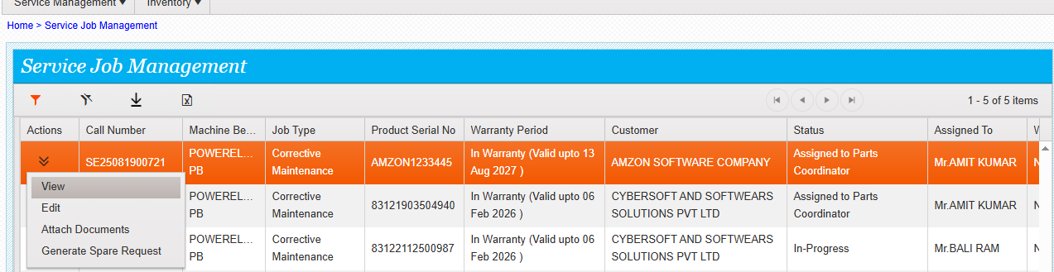

Go to parts recommended screen and see the parts details

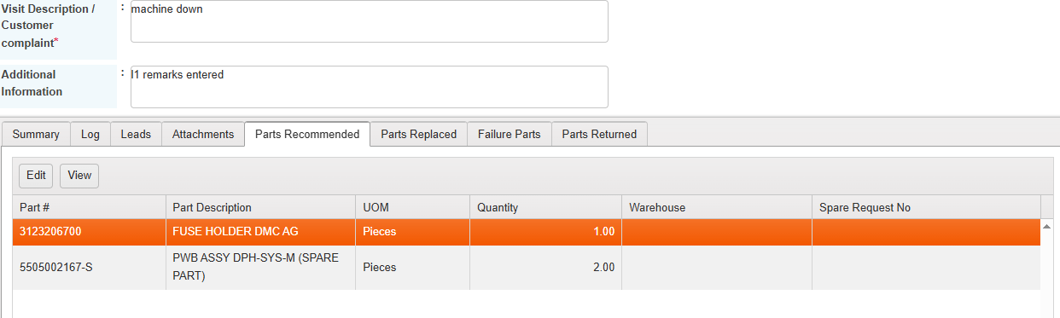

Click on the part and do the edit – and update the warehouse / the mapped warehouse list will be available to select/ If it is a third party warehouse then system will show the stock qty.

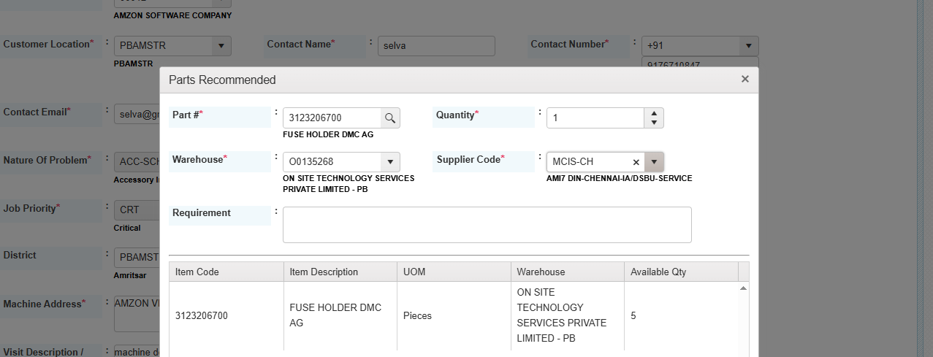

Select the warehouse and submit

Do the same for all recommended parts,

Warehouse selected for the recommended parts

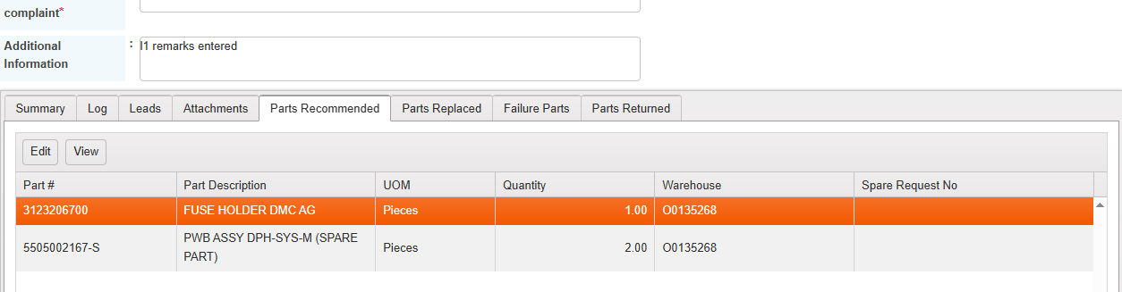

Call saved with warehouse details.

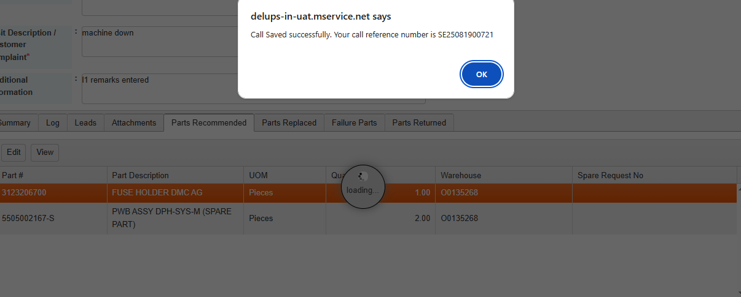

Go to action -- click on generate spare request

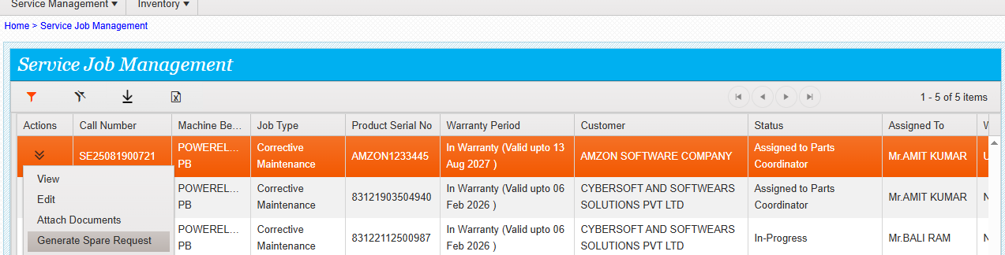

System will show the below alert , once you clicked OK, Then system will generate the spares request .

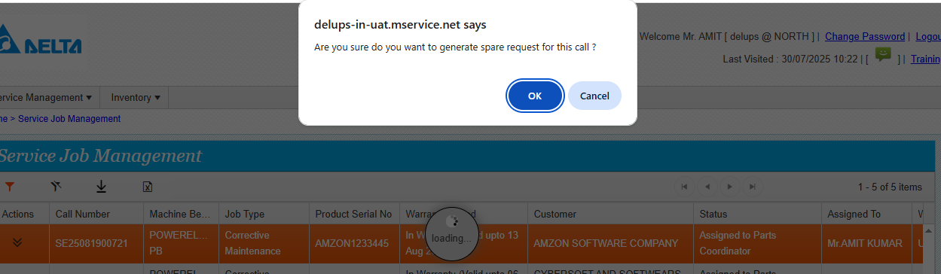

Spares request generated successfully,

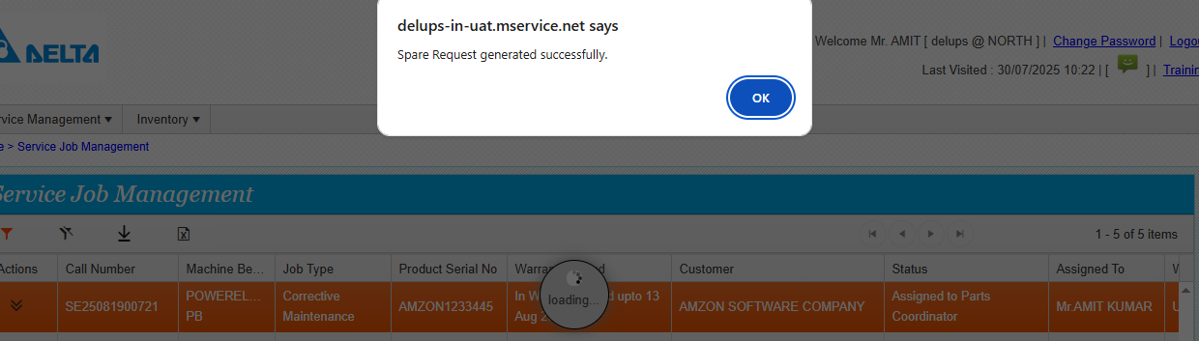

Job status changed to waiting for parts

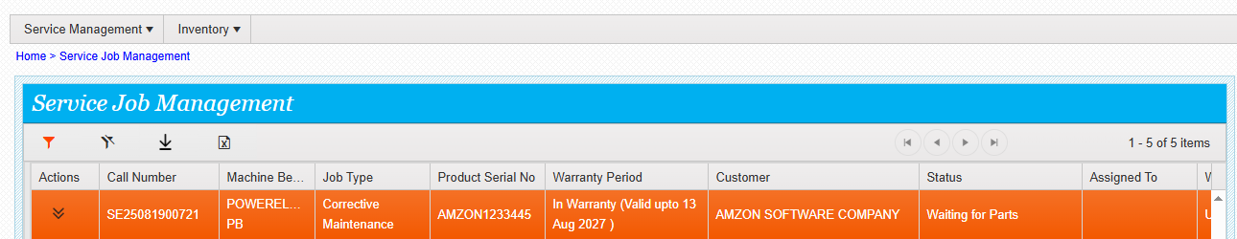

Spare request link will be available in service job management .click on the link and go to spare request management.

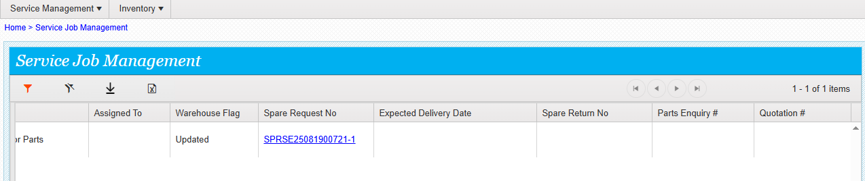

Spare request is assigned to parts coordinator/status is submitted for approval.

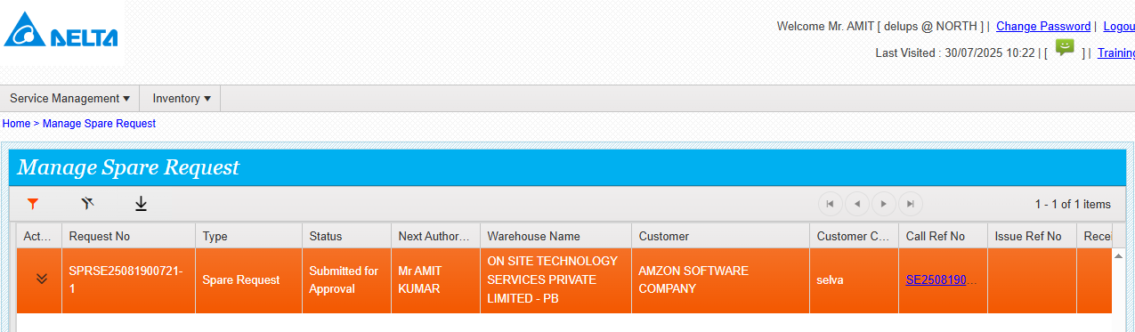

Go to action /click on view and see the parts details.

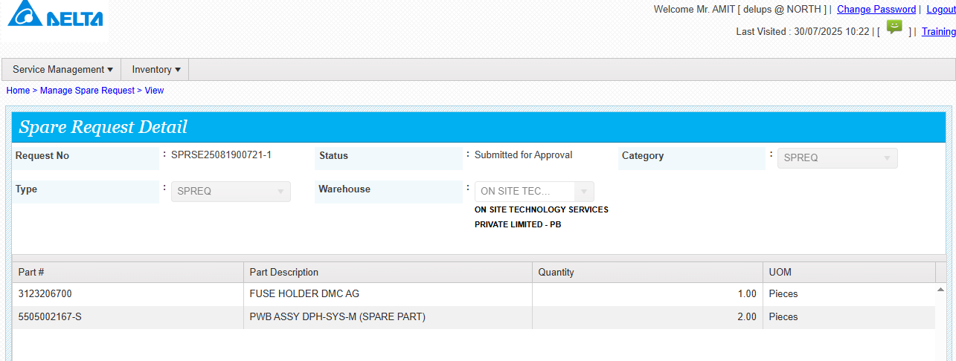

Click on approve action and see the below screen

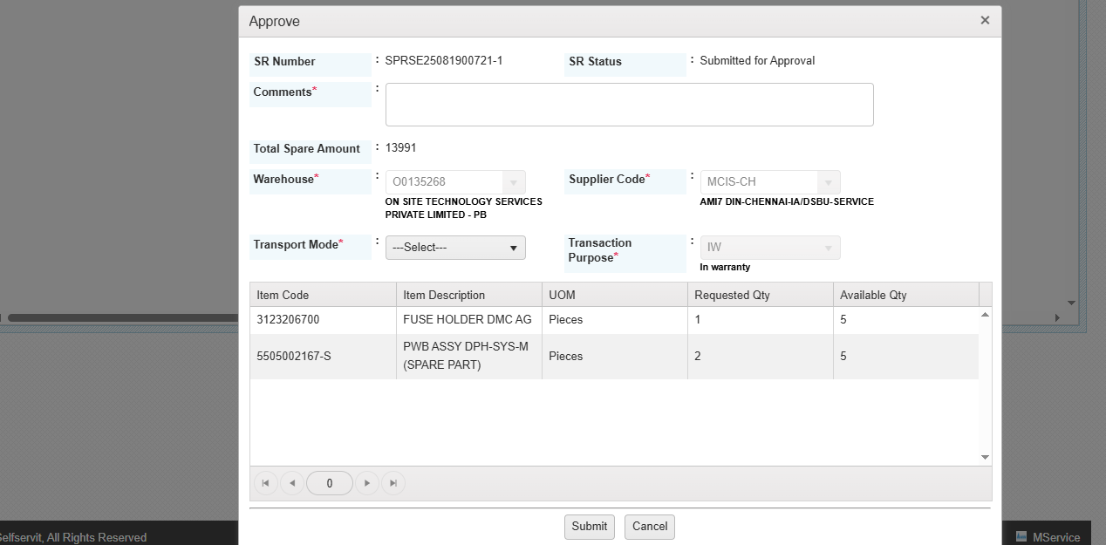

Select the transport mode and enter the comments and submit.

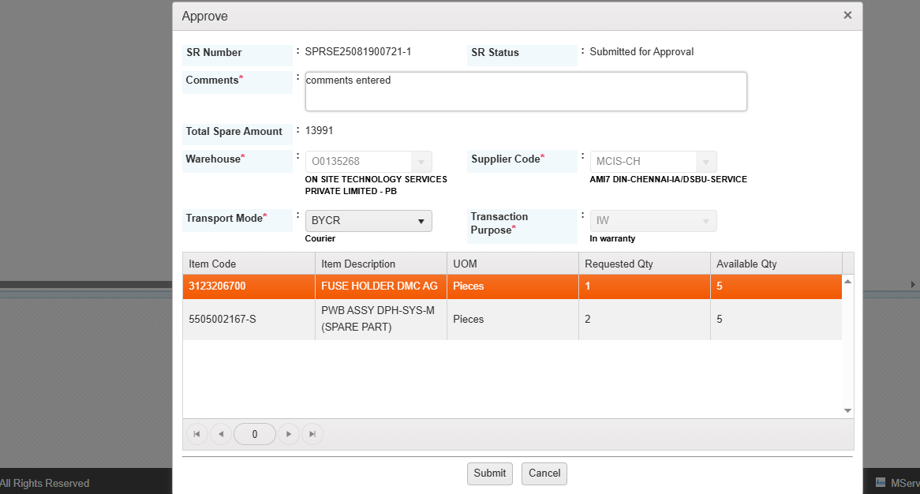

Approved done successfully.

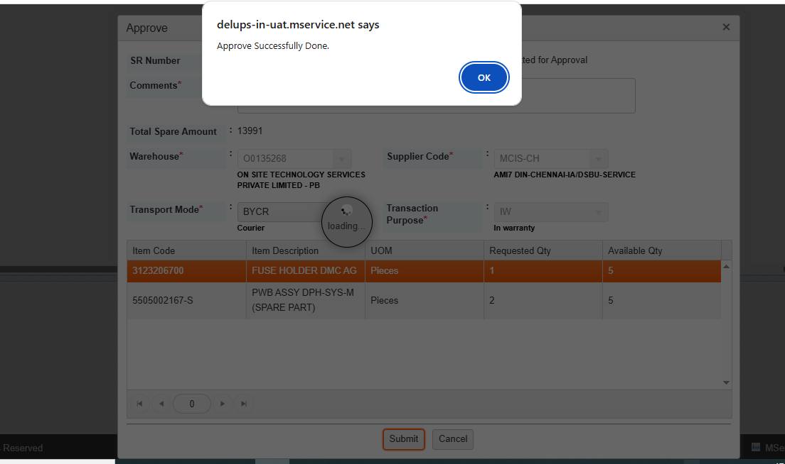

Once spare request is approved then system will generate the issue .Issue ink will be available . Issue will be assigned to the respective warehouse coordinator.

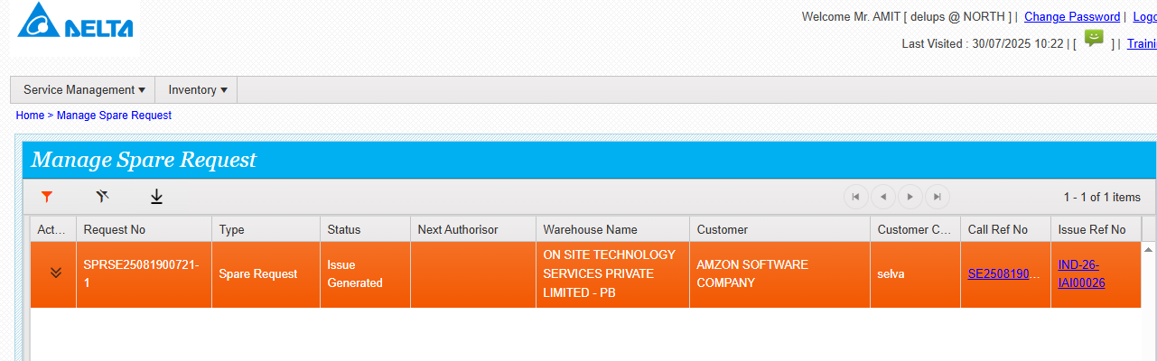

When the link is clicked then it will go the inventory issue module.

